Body Language

Teaching Notes
- Objective:
This activity is an extension to Lesson 2 (Body Language) in the Book 4 of Far East English Reader for Senior High Schools. Considering the increasing workload for the second-year senior high students, this activity won’t take the class too much time. The activity can be fun that contains group discussion and brief English play with proper gestures. The purpose of this activity lies in comparison and contrast between the body language in Taiwan and the USA. Two student sheets are attached to the lesson plan.
- Time:
30 minutes in total suggested.
- 5 minutes for explaining the activity and filling out the student sheet
- 25 minutes for group discussion and presentation
- Group:
5-6 people in one group (depending on the size of class)
- Attention:
- This activity doesn’t need students to prepare anything before the class. It can be used as an interesting quiz after the lecture on the textbook.
- The first student sheet is a quiz form. The second student sheet is a reference for group discussion and performance.

Procedure
Stage | Time | Content
1. | 3 minutes  2 minutes | - Give Student Sheet 1 to each pupil. Ask them to match the picture with a suitable expression.  - Pick students to give correct answers.  Answer Key:  a. 4, b. 7, c.1, d.5, e.8, f.2, g.6, h.3
2 | 2 minutes  5 minutes | - Divide students into groups. Give Student Sheet 2 to each group.  - Group Discussion:  - What are the gestures often used in Taiwan?  - Design a short English play in which at least 3 common gestures are used.  Option A: The half class performs western gestures; the half performs the Taiwanese for the contrast.  Option B: In each group, some students act as foreigners; others act as Taiwanese in the play.
3 | 15 minutes  3 minute | - Invite students to perform on stage.  - Give comments or draw a conclusion.

- Your comments or experience of using this activity are welcome. Please send to: hhcindylee@pchome.com.tw
Gesturers
Student Name: _______________

Look at these gestures. They are often used in the USA. Match each picture with a suitable expression.

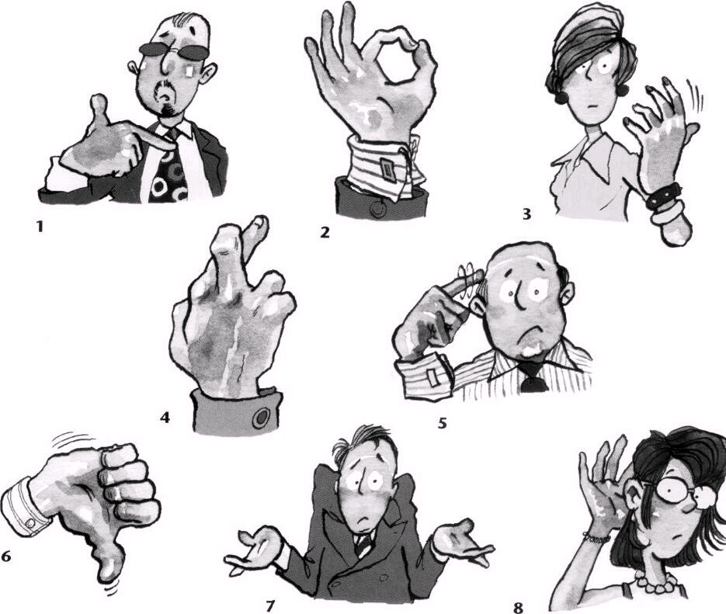

a. I hope nothing goes wrong.
b. I don’t know.
c. Who, me?
d. He’s crazy!
e. I can’t hear you.
f. OK!
g. That’s no good.
h. Come here.

Source: Barnard, R., Cady, J. (2002) Business Venture 2. Oxford: Oxford University Press.
Gesturers - Group Play
Discussion Outline
Group Members:_______________________________________

  - What gestures do people use in Taiwan?
在台灣大家常用什麼樣的手勢來輔助語言的表達呢?

Gesture/手勢 | Meaning/ 涵義
1.
2.
3.

  - Story Line / 劇本 (本齣短劇須表演至少三種手勢)
表演前,別忘了告訴觀眾,你的場景和演員是代表哪一個國家喔!

- Beginning
故事的開端
(手勢一)
- Climax
中間精采之處
(手勢二)

- End
故事的結尾
(手勢三)

