Requesting A Proper Time to Meet

Teaching Notes
- Objective:
This activity is an extension to Lesson 5 (Making Requests) in the Book 4 of Far East English Reader for Senior High Schools. Considering the increasing workload for the second-year senior high students, this pair-work activity won’t take the class too much time. The activity combines a reading material on cross-cultural differences of office time and an exercise of useful conversation patterns.
- Time:
30 minutes in total suggested.
- 15 minutes for explaining the activity and filling out the student sheet
- 15 minutes for group discussion and presentation
- Attention:
- This activity doesn’t need students to prepare anything before the class. It can be used as an interesting quiz after the lecture on the textbook.
- The first student sheet is a quiz form. The second student sheet is a reference for pair exercise and performance.
Procedure
Stage | Time | Content
1. | 5 minutes  5 minutes | - Give Student Sheet 1 to each pupil. Ask them to fill out the blanks. Some blanks are numbers; others are weekdays.  - Pick students to give correct answers and read aloud the sentences.  Answer Key:  1. Fridays 2. 8:00 3. 4-5 4. August 5. 7:30 6. Friday 7. Thursday 8. 1:00 9. 1:30 10. January
2 | 10 minutes | - Divide students into pairs. Give Student Sheet 2 to each person.  - Ask students to practice the Q & A.  3) Ask pair to design their own dialogue.
3 | 10 minutes | - Invite pairs to perform their dialogues.  - Give comments or draw a conclusion.
- Your comments or experience of using this task are welcome. Please send to: hhcindylee@pchome.com.tw
Good Time or Bad Time?
Student Name: _______________ Score:______________

Germany
Some offices close by 2:00 or 3:00 p.m. on 1. _________ ( weekday).

Argentina
Argentinian executives sometimes work very long hours, often finishing work at 10 p.m., so a business meeting at 2. ________ p.m. is not unusual.

France
Most people take 3. ________ weeks’ summer vacation in July and 4. ________.
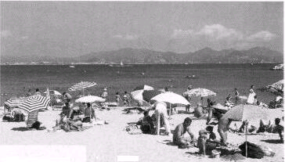
Switzerland
The working week is generally Monday through Friday form 5. ______ a.m. to 5:30 p.m., with a one-or two-hour lunch break.

Saudi Arabia
6. __________ (weekday) is the Muslim holy day, and businesses are closed. Many business are closed on 7. _________ (weekday), too.

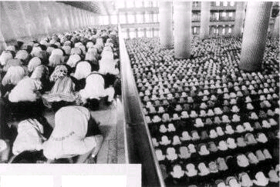
Taiwan
Most students and many business people take a nap after lunch between 8. ____ and 9. ______ p.m. The popular vacation period is 10. ______ through March.

Reference: Source: Barnard, R., Cady, J. (2002) Business Venture 2. Oxford: Oxford University Press.

Good Time or Bad Time?
Student Name: _______________

Questions:
-Are you free on Monday?
-Are you available on Tuesday?
-How much time do you have for a date on this Saturday?
-How long do you think we need to discuss this assignment?
-Do you have any time for hanging around on Sunday?
-Are you free for window-shopping on Saturday?

A. Invite your friend to do something:

Replies:
              - I am free from 7 till 9 on Saturday.
              - I am afraid that I am busy all day on Tuesday.
              - I’m free all morning. How long do we need?
              - Half an hour is enough, I guess.
              - Yes, I’m free then. Let’s have lunch together!

B. What is your reply?

