Worksheet 4-1-3
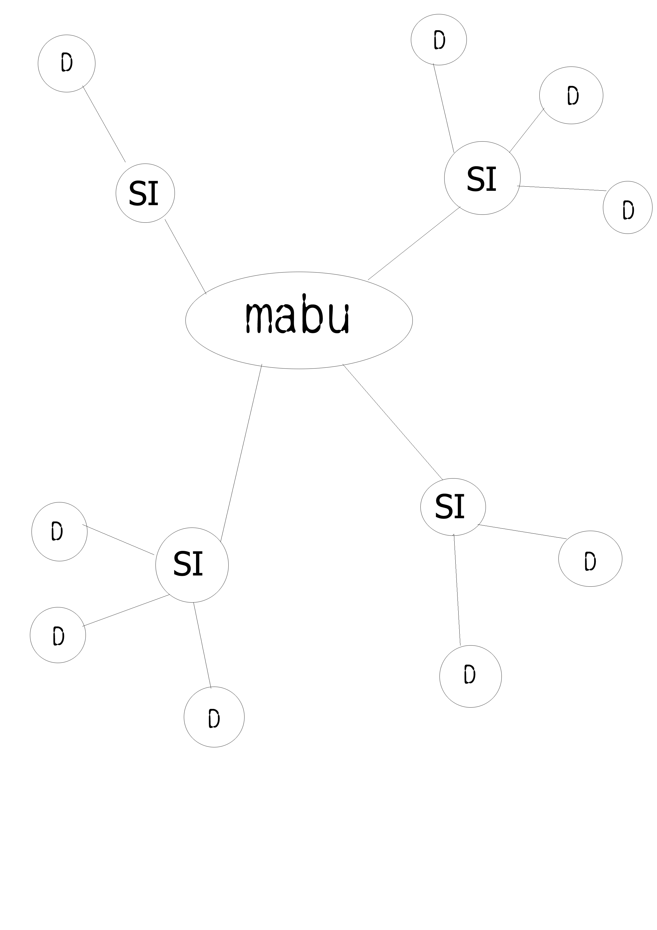 SI= Supporting idea, D= Details

