
Teaching Grammar in Your Class: Activities & Strategies
Presented by Dr. Bradley C. Gilpin
University of California Irvine, Extension
TESL Conference, Taiwan, November 2004

Teaching Philosophy
Create a relaxed classroom atmosphere to lower students affective filter
Teach grammar points in context to increase motivation
Raise student awareness of grammar points through authentic materials
Create activities that appeal to different learning styles
Integrate skills whenever possible
Ex. In a grammar lesson, include vocabulary, reading (skimming), speaking, and pronunciation.

Sample Lesson
Lesson Plan Handout – Teaching Present Continuous to Junior High/High School Students

Sample Large Group Activities for Reinforcing Grammar Points – (Present Continuous)
Matching
Tongue Twisters
Charades
Authentic Reading Search
Video Clip for Reinforcement
Additional Example Using Same Video Clip

Question/Answer

Sample Lesson Plan
Teaching Grammar in Your Class: Activities & Strategies
Presented by Dr. Bradley C. Gilpin
University of California Irvine, Extension

Level: Junior High/High School/Adult School

Note: This lesson plan could be applied in all levels of ESL by making a few modifications. In this activity the students will have the opportunity to speak, read, and listen to the English language. The activities presented here can be adapted to any aspect of grammar.

Goal: Students will reinforce their knowledge of the present continuous verb tense. Students will see the grammar they have been learning put to use in a meaningful way.

Objectives:
- Students will review the form and usage of the present continuous.
- Students will practice the present continuous by using various learning styles including: visual, auditory, kinesthetic
- Students will recognize the present continuous in authentic reading material, while at the same time practicing their skimming skills.
- Students will practice pronunciation skills while focusing on the present continuous.
- Students will become actively involved in the learning of the present continuous thereby bolstering their confidence in their English ability.

Warm-up activity:
Begin class by reviewing (teaching) the present continuous. Focus on the form (BE + V – ing) and usage (events occurring right now). Note: for higher level students, you may also want to inform them of the other uses of the present continuous (future, extended time). Make sure to focus on reductions (He’s eating).

Activities:
Note: Before beginning each activity, provide students with the necessary vocabulary for that activity.

Matching:
On the overhead projector, show grid which has pictures covered with post-it notes. Split students into two or more teams. Have one student from the first team make their first selection. Show that picture and have students in that team say what is happening. Listen and correct their usage of the present continuous. If a student says, “Dog sit,” model the correct form, “The dog is sitting,” and have the student(s) repeat after you. Have the same team make their second selection. Repeat above. If two pictures match, that team gets a point and continues. If the picture doesn’t match, the next team has a turn. Continue until all matches have been made. Tally the winning team.

Tongue Twisters:
On the overhead projector, show the tongue twisters. First have students find the present continuous verb forms in the text. Ask students why the present continuous is used in that situation.

Topics for Charades – Present Continuous
Dr. Bradley C. Gilpin, UC Irvine-Extension

You are opening a jar.
You are crossing a busy road.
You are making a cup of tea.
You are eating very spicy food.
You are driving a race car.
You are waiting for a bus.
You are waiting for the dentist.
You are reading a very sad story.
You are changing a baby’s diapers.
You are trying to stay awake in grammar class.
You are trying to catch a mosquito.
You are sunbathing at the beach.
You are watching a comedy on TV.

Tongue Twisters for Present Continuous
Dr. Bradley C. Gilpin, UC Irvine-Extension

Gertie’s great-grandma is growing aghast at Gertie’s grammar.

While we’re talking, we’re watching window washers wash Washington’s windows with warm washing water.

Sally is selling sea shells by the sea shore.
The shells she’s selling are surely seashells.
So if she is selling shells on the seashore,
I’m sure she’s selling seashore shells.

There was a young fisher named Fischer
Who fished for a fish in a fissure.
The fish with a grin,
Pulled the fisherman in;
Now they’re fishing the fissure for Fischer.

Sample “Authentic” Reading Search Article
Dr. Bradley C. Gilpin, UC Irvine-Extension

Ancient Bird Fossil May Suggest Link with Dinosaurs
Fri Oct 22, 4:17 pm ET(from Yahoo! News)

WASHINGTON (Reuters) – Scientists in China are researching a 120 million-year-old fossil of a baby bird which is believed to have died just before it hatched. This discovery is shedding light on the relationship between dinosaurs and birds.

The discovery of the bird, with a well-developed skull, large curved claws and feathers, is also giving insight into when complex behavior like caring for helpless young first began to evolve.

It is lending credence to the idea that birds of that era, like dinosaurs, were sufficiently developed at birth to function on their own immediately after they hatched.

The discovery was described by Zhonghe Zhou and Fucheng Zhang of the Chinese Academy of Sciences in Friday’s issue of the journal Science.

The fossil chick was found in deposits in Liaoning in northeast China. While there is no eggshell, the little body is curled up into an egg-shaped space and looks like a developing chick.

Many researchers are developing theories that birds and dinosaurs evolved from the same ancestor. This month alone fossils have been reported showing that Tryannosaurs had feathers and that a related dinosaur slept curled up like a bird.

Scientists are saying that the earliest known bird is the 150 million-year-old. Archaeopteryx although they have also discovered a 200 million-year-old feathered dinosaur fossil.

Matching Activity
Dr. Bradley C. Gilpin, UC Irvine-Extension

 | A | B | C | D
1
2 |  | 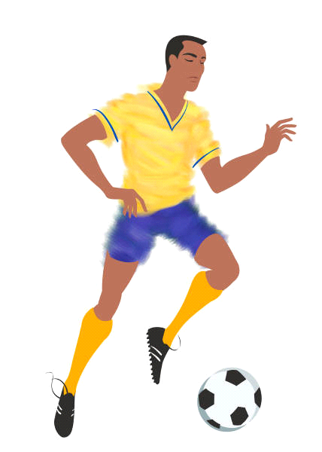
3 |  | 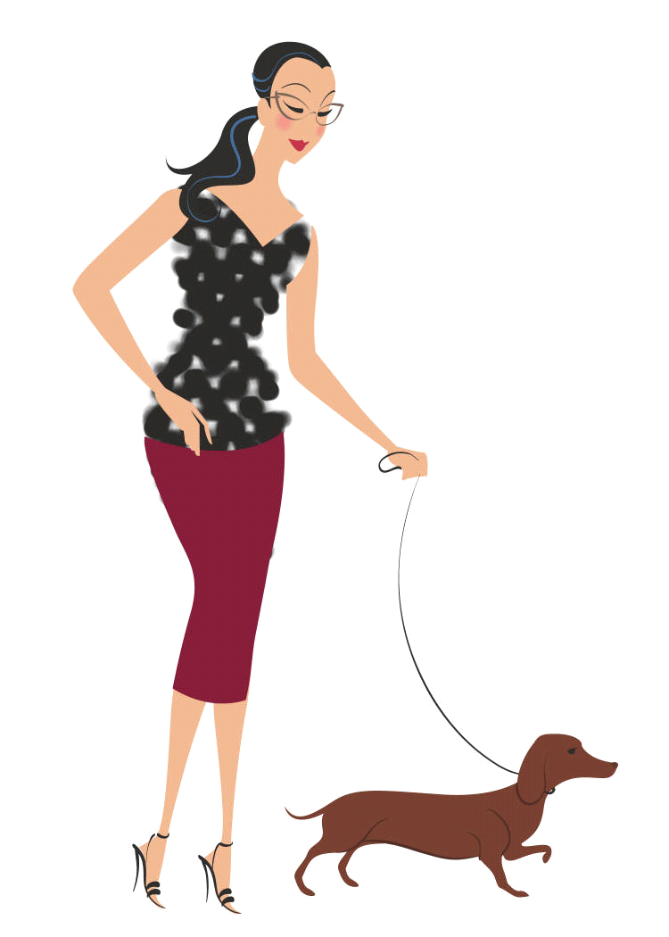
4
5

Model the tongue twister, emphasizing the present conditions. Have the students read the text in chorus. Ask for volunteers to try individually. Help as needed.

Charade (2 variations)
- Write simple sentences containing the present continuous on small cards (You are driving a car.) Have individual students come to the front of the class and act out what is on the card. Students in the class (individual or as a class) guess what the person is doing. Monitor responses and focus students on the present continuous (He is driving a car.) In a large class, this can be done in groups. Divide the class into groups. Have one student from each group act out and the others guess. As you will have to monitor and correct all groups, try to keep the number of groups to a maximum of 4.
- Have 1-4 students come to the front and face the class. Show the same sentences mentioned above on the overhead projector. Have the entire class act out the sentence and have the student(s) at the front of the class guess the answer, again focusing their responses on the present continuous.

Authentic Reading Search.
Copy an excerpt of a text or article that will be interesting to the students. It is ok if the text is too difficult for them. Either give each student a handout of the text or project it on the overhead. Have students individually or in pairs/groups find examples of the present continuous in the text. They don’t have to understand the meaning of the text to find the verb forms. This is a good exercise to build skimming skills which will improve reading speed and also to show students that they are “reading” the same materials as native speakers.
Follow up with a video excerpt of the same passage if possible. While watching the video, explain what is happening by focusing on the present continuous.

Video Clip Reinforcement Activity
Hand out prepared narrative of a video clip of your choosing which enforces present progressive. Leave blanks where present progressive is to be used. Have students work individually or in pairs to filling the blanks with the appropriate verb forms. After students complete this task, have them check their answers with a partner or group. Then go over the answers as a class. After that, show the video clip with the sound turned down. As the clip is playing, read the narrative to the students. This way, students can see how the activity they just finished translates to a “real life’ situation.

Review:
After completing these activities, students should have a good idea of how the present continuous is used. Review form and usage of the present continuous briefly.

Homework:
Have students find one passage in English text (magazine, newspaper, internet) of interest to them. Have them copy/print out the passage. Have students highlight all occurrences of the present continuous.
You can then have them get together with a partner the following day in class and check to see what they found was really present continuous. They can also discuss why present continuous was used in that situation.

